# Accessible Toilet Rooms

Below are a host of specifications for toilet rooms. This document is meant to be a primer for you and your business. If your issue is not addressed here, please refer to the end of the document for comprehensive resources to ensure your business is accessible.

The toilet room must have adequate space to allow a 5-foot diameter turning circle to allow a wheelchair to turn 180 degrees.

# Toilet Area

* Toilet bowl centered between 16 inches and 18 inches from a side wall, toilet seat between 17 inches and 19 inches above the floor.
* The toilet area is minimum of 60 inches wide, measured from the wall next to the toilet and 48 inches of clear floor space from the front of the toilet bowl to the compartment/room wall or at least 78 inches measured from the wall behind the toilet (Refer to Figure 1). Diaper changing tables are not allowed in the wheelchair accessible toilet compartment.
* Compartment door opening 32 inches minimum with self-closing door and locking hardware easy to operate without requiring tight grabbing, pinching or twisting.
* Flush valve should be located on the wide side of the toilet area mounted no more than 48 inches above the floor.
* Both horizontal and vertical grab bars must be provided as shown (Refer to Figures 2 and 3). Toilet paper dispenser mounted below the horizontal grab.
* If there are 2 or more toilet compartments in a room an ambulatory-accessible compartment measuring 36 inches wide must be provided in addition to the wheelchair-accessible compartment.
* If there are two or more urinals at least one urinal must be mounted with the rim no more than 17 inches above the floor.

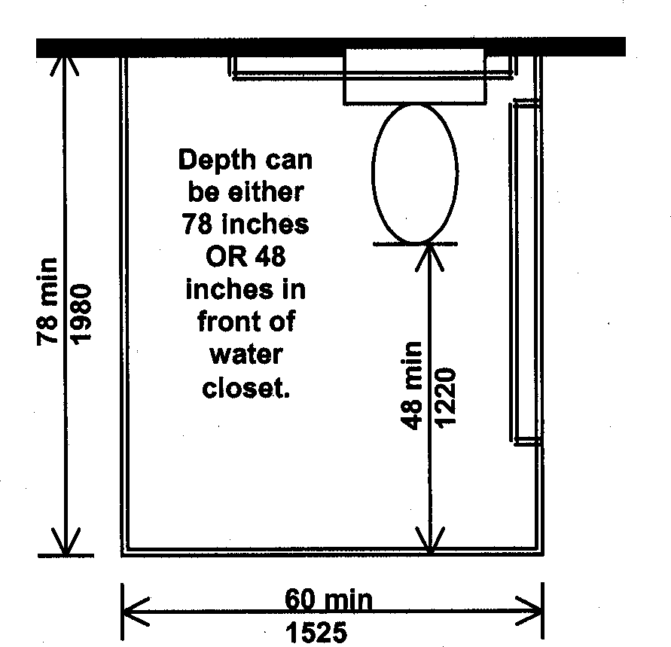

Figure 1: Diagram of accessible toilet stall

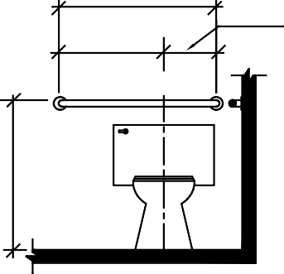

36 min

915

12 min

305

24 min

610

CL

Figure 2: Grab bar location behind toilet

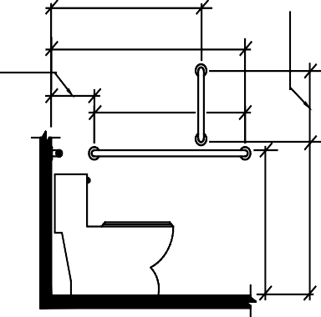

12 max

305

39 * 41

990 * 1040

54 min

1370

42 min

1065

Section 609.4

33 * 36

840 * 915

Section 609.4

18 m in

455

Figure 3: Grab bar location beside toilet

33 * 36

840 * 915

39 * 41

990 * 1040

# Sink Area

* Maximum height of the rim of the sink 34 inches above the floor with mirror mounted no higher than 40 inches to the bottom reflective edge.
* Faucets (level handles or electronically controlled) must be operable with one hand and not requiring tight grasping, pinching, or twisting of the wrist. Self-closing faucets that require both reaching forward and pushing down to activate are not recommended. Self-closing faucet must flow for a minimum of 10 seconds.
* There must be clear floor space 30 inches wide by 48 inches long in front of the sink for a forward approach with knee and toe clearance.
* Plumbing must be insulated or otherwise covered so that there are no sharp, abrasive, or hot edges exposed.
* Minimum of 27 inches of knee clearance from the floor to the bottom of the apron or counter and at least 8 inches back from the front edge. Toe clearance must extend at least 17 inches back from the front edge at a height of 9 inches above the floor (Refer to Figure 4). Knee and toe clearances must be at least 30 inches in width.

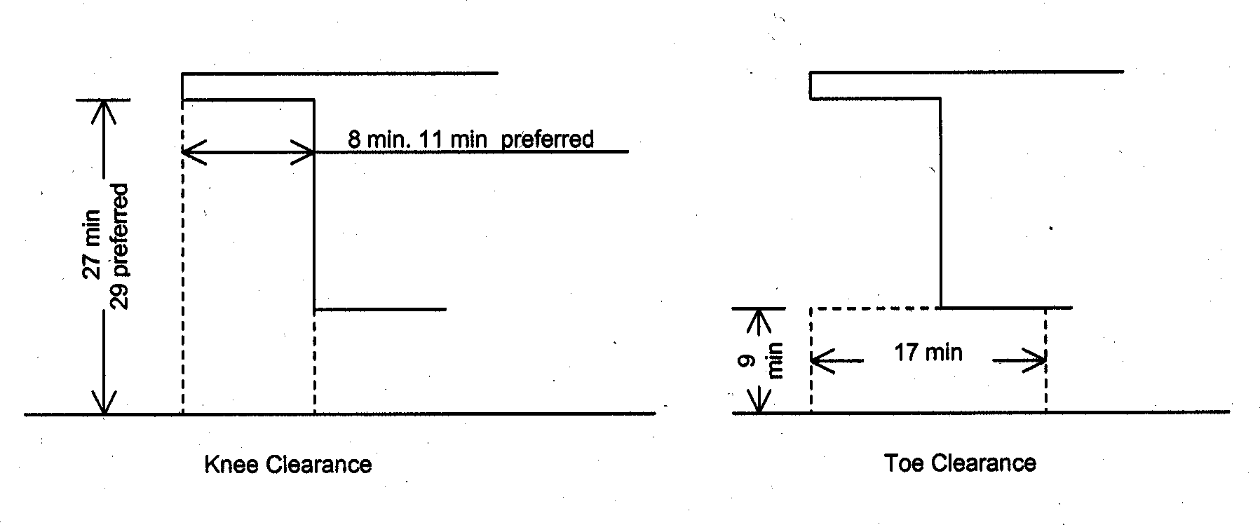

Figure 4: Knee and toe clearances

# Accessories

At least one of each type of accessory (soap dispenser, towel dispenser, etc.) shall be mounted such that the operating mechanism is no more than 48 inches above the floor with a clear floor space 30 inches wide by 48 inches long in front of or adjacent to the fixture or accessory (Refer to Figures 5). **Note:** accessories may share the same clear floor space.

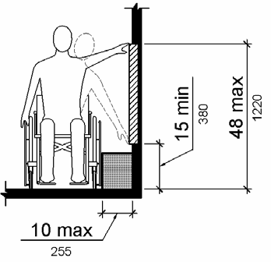

Figure 5: Unobstructed reach range

Thank you to the Minnesota Council on Disability for the content of this document.