Accessible Entrances

Below are a host of specifications for entrances. This document is meant to be a primer for you and your business. If your issue is not addressed here please refer to the end of the document for comprehensive resources to ensure your business is accessible.

An accessible entrance is essential to making a building usable by people with mobility disabilities. Even one step at an entrance can prevent access. Where steps exist at an entrance, access can be achieved in a variety of ways – for example adding a walkway or ramp, modifying the area to eliminate the steps or installing an enclosed lift. Consult your local building official to determine what is feasible at your location.

# In most instances an accessible walkway will be required, if adding a walkway:

* If outside, slope no greater than 1:20 (5%) with cross slope no greater than 1:48 (2%).
* Minimum of 48 inches wide.
* Surface of the walkway must be firm, stable, and slip-resistant.
* Changes in level between ¼ inch and ½ inch must have beveled edges.
* If gratings are located within the walkway, spaces no greater than ½ inch wide allowed with the long dimension perpendicular to the direction of travel.
* Curb ramps must be provided along the accessible route where necessary (i.e. along the accessible route to transition from parking or drop-off, to sidewalk).

# In some instances your building official will recommend a ramp, if adding a ramp:

* Slope no greater than 1:12 (8.3%) with cross slope no greater than 1:48 (2%).
* Minimum of 36 inches wide if indoors, or 48 inches wide if outdoors.
* Surface of the ramp must be firm, stable, and slip-resistant.
* 5-foot landing measured in the direction of travel of the ramp at top and bottom of the ramp.
* If the rise of a ramp run exceeds 6 inches handrails must be provided on both sides of the ramp run. (Further specs on handrails available from accompanying links).
* If the ramp changes direction at an intermediate landing a turning space must be provided on the landing (generally a 5-foot diameter circle).

# Some criteria for determining which entrances should be accessible include:

* If it is referred to as the “main entrance” to the building. (If you asked for directions to this building, you would be directed to this entrance.)
* If it provides the most direct access to main corridors and elevators (if present) as well as major public function spaces at the entry level such as an auditorium or cafeteria.
* If it is an entrance that people use when they enter the building from visitor or staff parking areas.

# Entrance Specifications

* With door in a 90 degree open position there must a minimum of 32 inches of clear space from the face of the door to the latch side doorstop (exception: doors not requiring passage, such as shallow closets, may have clear openings of 20 inches minimum). (Refer to Figure 1)
* If there are two sets of doors in a series, as in a vestibule, there must be a minimum distance between the doors of 4 feet plus the width of the in-swinging door as well as a 5 foot diameter circle of turning space (Refer to Figure 1).
* Threshold should be no more than ½ inch in height, beveled if above ¼ inch (Refer to Figure 2).
* Door hardware must be operable by a single effort with one hand not requiring tight grasping, pinching or twisting of the wrist, such as a lever (Refer to Figure 3) or loop style.
* Where two-way communication systems are provided to gain entry to a facility or to restricted spaces, they must include visual and audible signals to accommodate people with hearing, speech, or visual disabilities. This applies to all entrances equipped with such systems, including those that are inaccessible. Lighted signals should have labels to indicate their meaning. If handsets are provided, cords must be at least 29” long. If a telephone entry system is provided it shall comply with the ANSI/DASMA 303 Standard which requires a means for connecting a TTY.
* Force required to open interior doors should be no more than 5 lbs. Force recommended for exterior doors is 5-10 lbs.
* Minimum of 18 inches of clear space on the latch side from the pull side of the door and if the door has both a closer and a latch, is there a minimum of 12 inches of clear space on the latch side from the push side of the door (not required for doors with automatic opener). (Refer to Figure 4)
* Interior automatic push button control should be mounted 30 to 36 inches above the floor.

# Exterior automatic push button control must be mounted 30 to 36 inches above the ground and be located outside the sweep of the door.

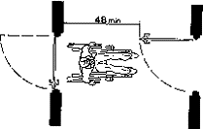

Figure 1: Vestibule clearance

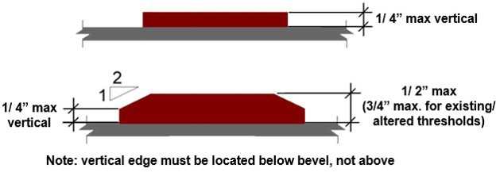

Figure 2: Threshold Specifications

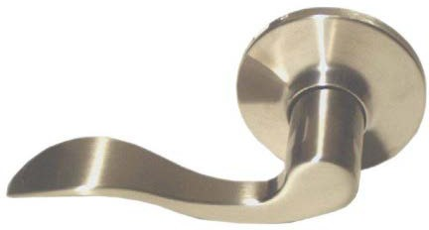

Figure 3: Accessible door hardware

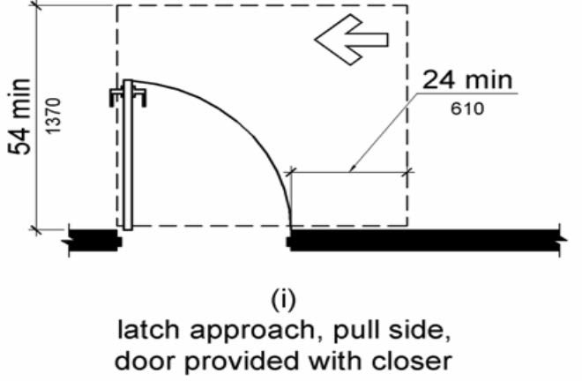

Figure 4: Door clearance

Thank you to the Minnesota Council on Disability for the content of this guide.